**Dataset**

use bankdatabase

db.bank.insertMany(

[{

"_id": {

"$oid": "62933bbf2864c5023afcee09"

},

"age": "56",

"job": "housemaid",

"marital": "married",

"education": "basic.4y",

"default": "no",

"housing": "no",

"loan": "no",

"contact": "telephone",

"month": "may",

"day_of_week": "mon",

"duration": "261",

"campaign": "1",

"pdays": "999",

"previous": "0",

"poutcome": "nonexistent",

"emp": {

"var": {

"rate": "1.1"

}

},

"cons": {

"price": {

"idx": "93.994"

},

"conf": {

"idx": "-36.4"

}

},

"euribor3m": "4.857",

"nr": {

"employed": "5191"

},

"y": "no"

}

**MongoDb Queries of the Bank Dataset**

1. MongoDB query to display the first 10 bank details who’s age=56.

* db.bank.find({"age": "56"},{_id:0}).limit(10).pretty()



1. MongoDB query to display all the documents in the collection in the bank

* db.bank.find({},{_id:0}).pretty()



1. MongoDB query to find the banks which locate in latitude value less than -65.543.

* db.bank.find({“address.coord”:{$lt:-65.5443}});

1. MongoDB query to display all the bank detailswhose marital is married.

* db.bank.find({"marital": "married"},{_id:0}).pretty()

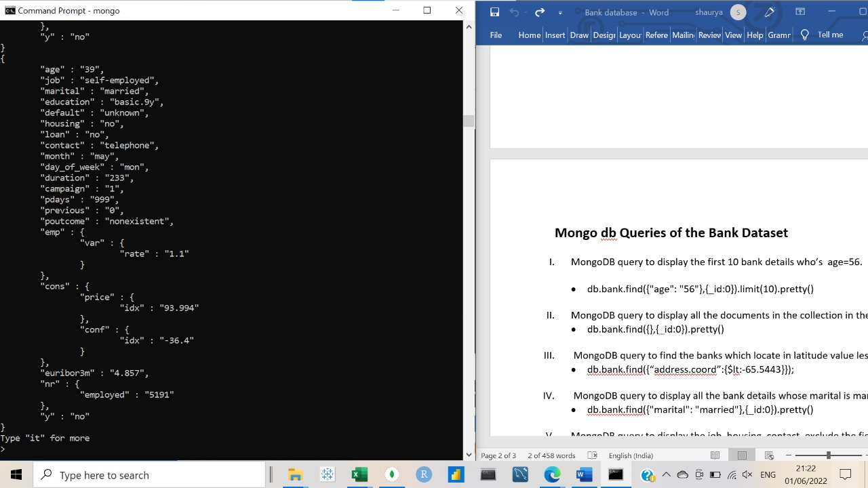

1. MongoDB query to display the job, housing,contact, exclude the field _id for all the documents in the collection bank.

* db.bank.find({},{"job":1, "housing":1,"contact":1},{_id:0}).pretty()

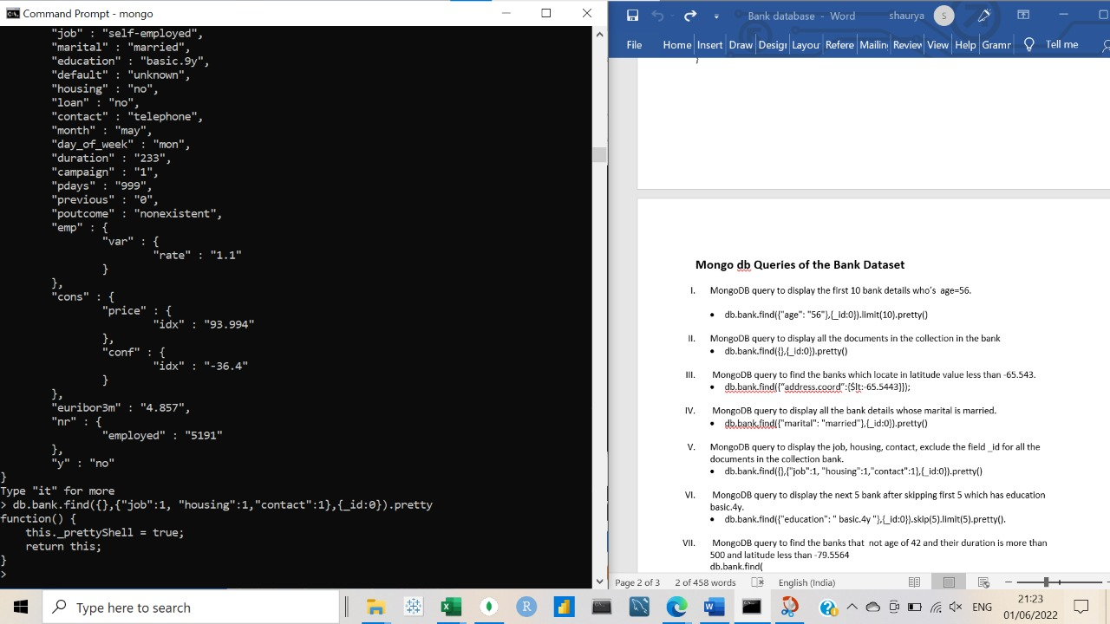

1. MongoDB query to display the next 5 bank after skipping first 5 which has education basic.4y.

* db.bank.find({"education": "basic.4y"},{_id:0}).skip(5).limit(5).pretty().

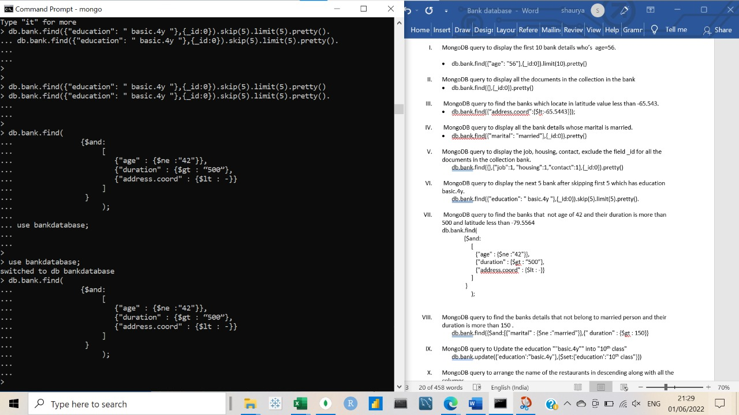

1. MongoDB query to find the banks that not age of 42 and their duration is more than 500 and latitude less than -79.5564

db.bank.find(

{$and:

[

{"age" : {$ne :"42"}},

{"duration" : {$gt : “500”},

{"address.coord" : {$lt : -79.5564}}

]

}

);

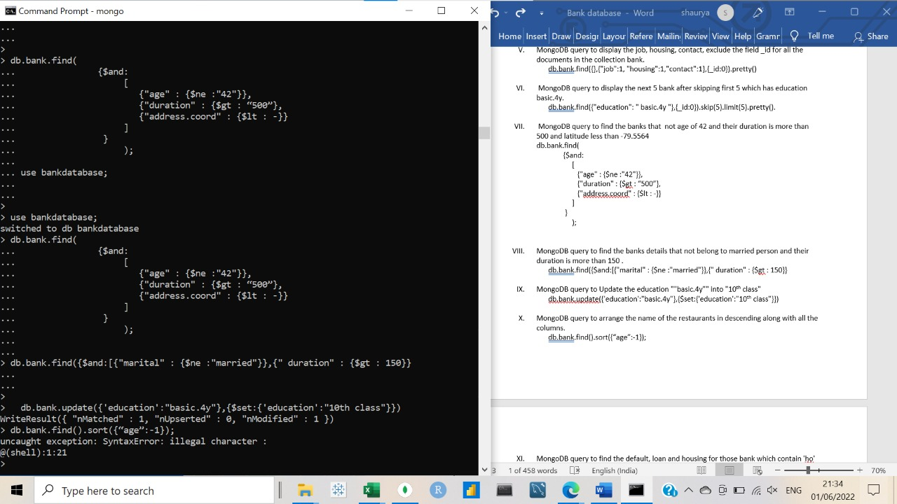

1. MongoDB query to find the banks details that not belong to married person and their duration is more than 150.

* db.bank.find({$and:[{"marital" : {$ne :"married"}},{" duration" : {$gt : 150}}

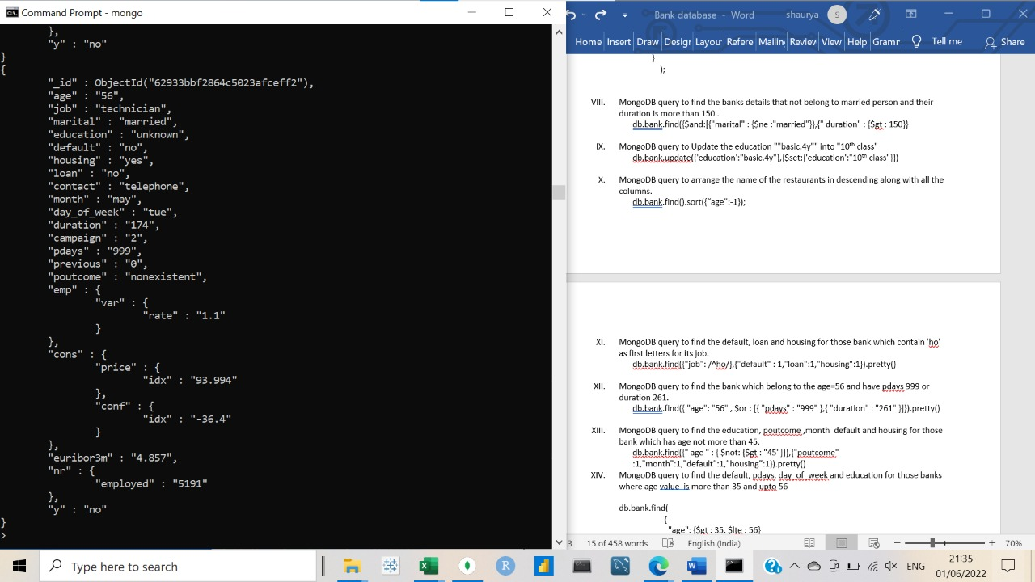

1. MongoDB query to Update the education ""basic.4y"" into "10th class"

* db.bank.update({'education':"basic.4y"},{$set:{'education':"10th class"}})

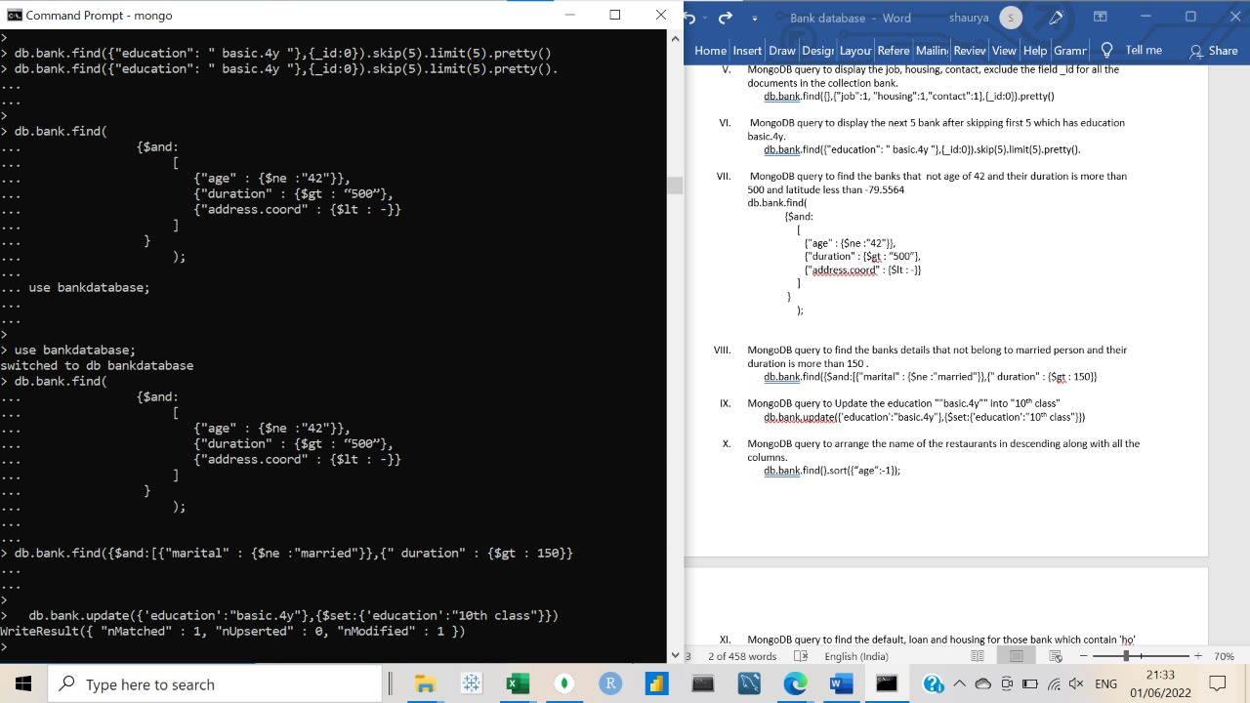

1. MongoDB query to arrange the name of the restaurants in descending along with all the columns.

* db.bank.find().sort({“age”:-1});

1. MongoDB query to find the default, loan and housing for those bank which contain 'ho' as first letters for its job.

* db.bank.find({"job": /^ho/},{"default" : 1,"loan":1,"housing":1}).pretty()

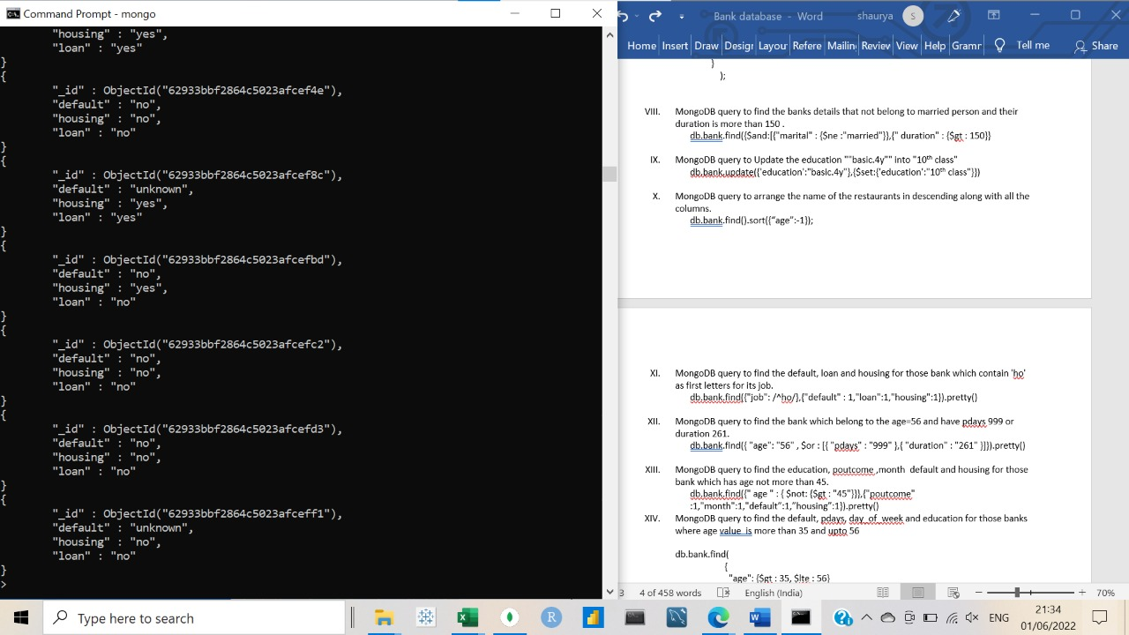

1. MongoDB query to find the bank which belong to the age=56 and have pdays 999 or duration 261.

* db.bank.find({ "age": "56" , $or : [{ "pdays" : "999" },{ "duration" : "261" }]}).pretty()

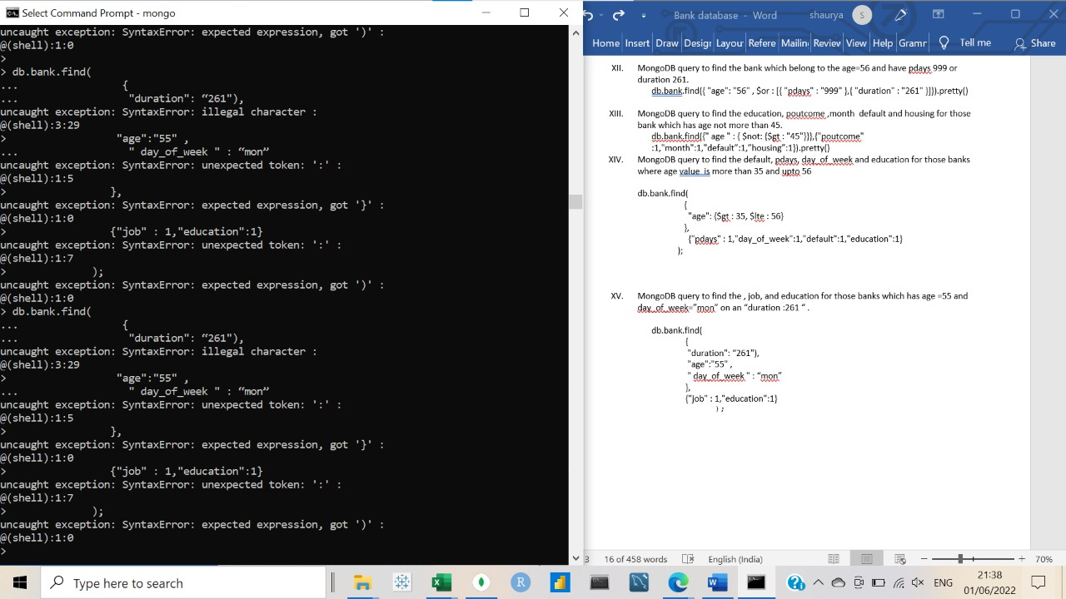

1. MongoDB query to find the education, poutcome,month default and housing for those bank which has age not more than 45.

* db.bank.find({" age " : { $not: {$gt : "45"}}},{"poutcome" :1,"month":1,"default”:1,”housing”:1}).pretty()

1. MongoDB query to find the default, pdays, day_of_weekand education for those banks where age value is more than 35 and upto 56

db.bank.find(

{

"age": {$gt : 35, $lte : 56}

},

{"pdays" : 1,"day_of_week":1,"default":1,"education":1}

);

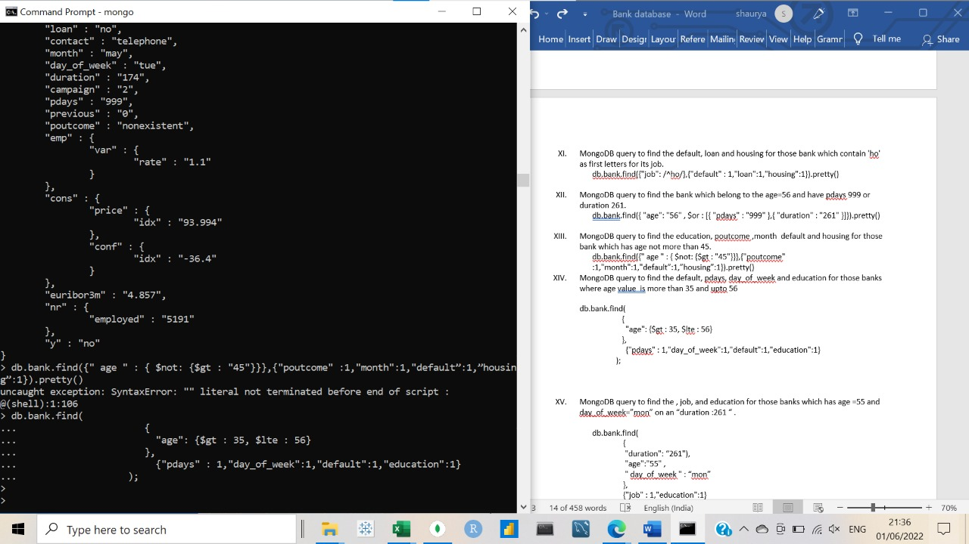

1. MongoDB query to find the , job, and education for those banks which has age =55 and day_of_week=”mon” on an “duration :261 “.

db.bank.find(

{

"duration": “261"),

"age":"55" ,

"day_of_week" : “mon”

},

{"job" : 1,"education":1}

);

